Assignment I

Deadline: Mon. 14 April 2015
1. A client attempts to synchronize with a time server. It records the round-trip times and timestamps returned by the server in the table below. Which of these times should it use to set its clock? To what time should it set it? Estimate the accuracy of the setting with respect to the server’s clock. If it is known that the time between sending and receiving a message in the system concerned is at least 8 ms, do your answers change?
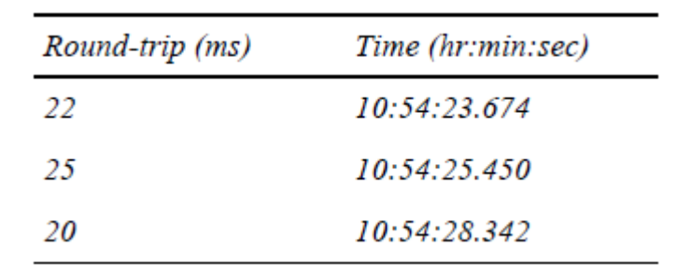
Sample Solution:
The client should choose the minimum round-trip time of 20 ms = 0.02 s. It then estimates the current time to be 10:54:28.342 + 0.02/2 = 10:54:28.352. The accuracy is ± 10 ms.
If the minimum message transfer time is known to be 8 ms, then the setting remains the same but the accuracy improves to ± 2 ms.

2. By using timestamp vectors to represent logical times, prove:
a) if neither T_{a} ≤ T_{b} nor T_{a} ≥ T_{b}, then a||b;
b) if T_{a} ≤ T_{b}, then a →b;
where T_{a} and T_{b} are timestamp vectors of events a and b, respectively.
Hint: 1) prove “if a →b, then T_{a} ≤ T_{b}” first; 2) then use “contradiction” to prove (a) (i.e., neither “a →b” nor “b →a” can be true); 3) using statement of (1) and (a), prove (b).

Sample Solution: a)
Proof: follow question (3), prove:
if a →b, then T_{a} ≤ T_{b} … (1)
Suppose a||b is not true, there’re two possibilities, a →b or b →a.
If a →b, then from the above statement (1), T_{a} ≤ T_{b}, which contradicts with the assumption. So a →b cannot be true.
Similarly, we can prove b →a cannot be true.
So either a →b nor b →a, which leaves a||b.

Sample Solution: b)
Proof: First, we can prove that b →a is not true from statement (1).
Then, we can prove a||b doesn’t hold.
According to the definition of a||b, there’d be one element i, such that T_{a} [i] < T_{b}[i] and another element j, such that T_{a} [j] > T_{b}[j]. The latter half contradicts with T_{a} ≤ T_{b}. So a||b cannot be true.
Therefore, we have a →b.

3. Suppose you’re the administrator of cs.cityu.edu.hk domain. What operations are required when:
- add a new host named “pluto” into the dept’l network.
- create a new sub-domain named “ds” in the CS domain and a host “ds0” is assigned to be the name server for domain “ds.cs.cityu.edu.hk”.
- change the dept’l www server to host “homer”.

Answer:

  - suppose the dept domain is “cs.cityu.edu.hk” and the name server for this domain is mars.cs.cityu.edu.hk. You need to add an item in the database file “db.cs.cityu.edu.hk”:
pluto IN A 144.214.120.2

  - you need to add the following line in db.cs.cityu.edu.hk:
IN NS ds0.ds.cs.cityu.edu.hk
  - you need to add the following line in db.cs.cityu.edu.hk:
www.cs.cityu.edu.hk IN CNAME homer.cs.cityu.edu.hk
OR
www IN A 144.214.120.97

